**Exercise A**

Write a **program**, which adds the **2 numbers** „3“ and „25“, and stores the **result in memory cell „D0“**.

**Exercise B**

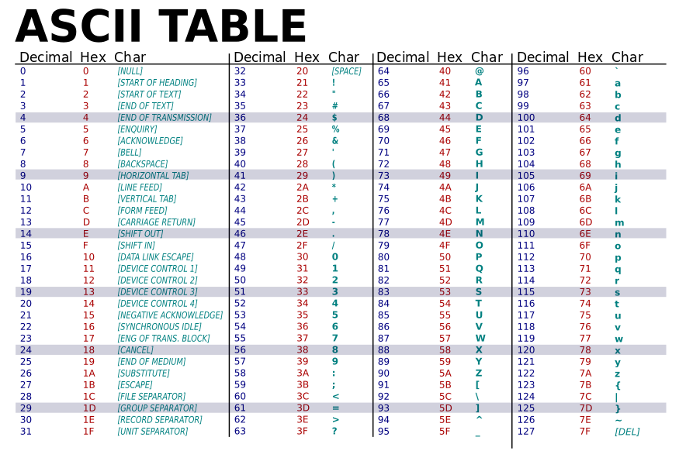Write a **program** for the virtual machine, in which you use the **ASCII Table** in order to output the words: **Hello World!**

**Exercise C**

Write a **program**, which **alternates** (every 500ms) between the following addresses

|  |  |  |
| --- | --- | --- |
| *B6* | *B7* | *B8* |
| *C6* | *C7* | *C8* |
| *D6* | *D7* | *D8* |

filling the current address with „FF“. The value should wander clockwise from cell to cell, so that in the Memory Usage Screen a small **animation** can be seen!

|  |  |  |
| --- | --- | --- |
| **FF** |  |  |
|  |  |  |
|  |  |  |

|  |  |  |
| --- | --- | --- |
|  | **FF** |  |
|  |  |  |
|  |  |  |

|  |  |  |
| --- | --- | --- |
|  |  | **FF** |
|  |  |  |
|  |  |  |

|  |  |  |
| --- | --- | --- |
|  |  |  |
|  |  | **FF** |
|  |  |  |

usw.

The program should have a loop which restarts at the beginning at its end.